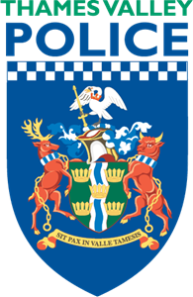

Community Speed Watch
Thames Valley Police & Community Speedwatch Online

VOLUNTEERS NEEDED

Community Speed Watch is a national initiative where proactive members of local communities, with the support from Thames Valley Police, record details of speeding vehicles.
- Speeding motorists will receive a letter from the police explaining the potential risks and consequences of their behaviour.
- People standing at the roadside are the heart and soul of the scheme; being seen by drivers at the roadside sends the message that antisocial and dangerous driving is not acceptable and is reinforced by the police warning letters.
- Parishioners repeatedly tell the Parish Councils and Police that speeding is one of their biggest concerns. and as we know from Speed Indicator Devices that speeding is at unacceptable levels on some of our roads.
- We want to help you set up a CSW group to tackle the problems in your areas. To enable this we need your help.

We need volunteers aged over 18. If you are interested and can spare just a few hours a month please send an email to: lee.turnham@thamesvalley.police.uk
- or take a look at the CommunitySpeedwatch.org website where you can find out more information.

Thank you

